Waqas Ahmad Rafique

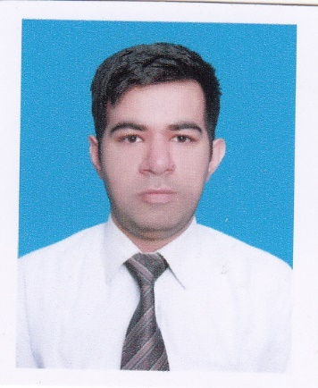

House # 28, Block # 4 Karim Park Yasin Road Lahore

Phone Number: +92-3224087911

Email: [ahmad.waqas37@yahoo.com](mailto:ahmad.waqas37@yahoo.com)

***SYNOPSIS***

I am a **ACCA Member** with strong interpersonal skills having experience in Accounts/Finance/Audit

Creative, result oriented, dynamic professional having strong professional education background of accounts, finance, audit, management, with **3.5 years** of experience in Internal Audit. Working experience in system-based environment, which entails Risk Assets Review, General Banking, Accounts, and Administration. Have full command of the Prudential Regulations. Committed team player with proven ability to meet and exceed set goals. Have ability to perform, guide, and supervise.

at Managerial level.

Working Capital Management Financial Analysis

Financial Reporting Internal Auditing

Budgeting and Forecasting Financial Management

E-Commerce

**Work Experience**

1)Company **Nagina Group of Companies**

Ellcot spinning mills limited

Prosperity weaving mills limited

Nagina cotton mills limited

Designation Internal Audit Officer

Duration 28 March 2017 To Present

2) Company **Selmore Pharmaceutical Pvt Ltd**

Designation Accounts Executive

Duration 01 Jan 2016 to Aug 2016

3)Company **Drug Pharm Pvt Ltd**

Designation AssistantAccounts Payables Manager

Duration March 2015 to July 2015

Experience Area’s Exposed to

**Nagina Group of Companies**

* Annual/Interim/Quarterly Accounts verification
* Physical Stock Take Monitoring on Monthly Basis on Every Ist of Month
* Receivable Audit from Recording to Receiving of cash from customer
* Local commission on local sales/foreign commission on foreign sales verification
* Construction Bills verification
* Contractor bills verification (Mills Packing, Contractual labour)
* SOP Making for YARN/WASTE Dispatch
* Late credits of receivables
* Store & Spares of mills store audit
* Payables Audit (PO, GRA, Invoice, PAYMENT)
* Developing of reports if required
* Making internal control & verification testing
* Payroll verification of all group companies mills
* Annual Bonus/Leave encashment verification
* Annual Cotton Balance payment verification/Audit

Experience Area’s Exposed to

**Selmore Pharmaceutical Pvt Ltd**

* Implement best practice in the Financial and Accounting System.
* To Calculating Import Raw Material Cost, Dealing imports,
* To Closing Import, Calculate Imported raw material cost on SAP BUSINESS ONE.
* To Monitor accounts to ensure payments are up to date
* Close ledger of indenter Agent/Make payment against each L/C
* Negotiate with external vendors to secure the most advantageous terms
* Approve the ordering of necessary goods and services Finalize Details of Orders and Deliveries
* Handling Accounts Payable On Sap Business One
* To Check compliance with Internal Controls
* To Close L/C On SAP Business One
* To Enter A/P Invoices on Sap Business One
* To Resolve Pending Grn"s on Sap Business One
* Enter payments in SAP Business One
* Report to Manager Import and GM Finance & CEO

Experience Area’s Exposed to

**Drug Pharm (Pvt) Ltd**

* Identified, Suggested, Implemented and monitored new and
* Controls including preparation of SOP
* Review all ledger of Bank Accounts Verify Debit and Credit entries and also verify the Bank Charges and Interest
* Preparation of monthly payables report
* Monitor accounts to ensure payments are up to date
* Preparation of Monthly salary sheet
* Preparation of monthly payable ledger
* Preparation of Monthly output yield of each Batch Produce
* Maintain Accounts of Active Material / Inactive Material / Packing Material
* Making Batch Completion Report/ Batch yield/New Batch Allocation
* Import of Raw Material / Monthly audit or Raw Material and Packing Material
* Remove Production Bottleneck / Handle Daily Factory Operations
* Inventory Valuation of Finished Goods and Work in process
* Physical Stock Take of Finish Goods and Packing Material and Raw Material
* Handle Company Banks Accounts Check Issues for payments
* Reconcile accounts payable transactions

**Education & Professional Qualification**

2016 ACCA-UK Member.

P4 Advance Financial Management

P5 Advance Performance Management

2007 B. Com (IT) from Punjab University with 56% marks.

2005 I.COM from Bise Lahore 55% marks.

2003 Matric Science from Bise Lahore 51% marks

**ComputerLiteracy**

MS Office/ SAP Business One/ Quick Book

Tally and Latest Tally ERP. Oracle R12

**Personal**

Gender Male

Date of Birth March 22,1986

Nationality Pakistani

Languages Known English, Urdu

Marital Status Single