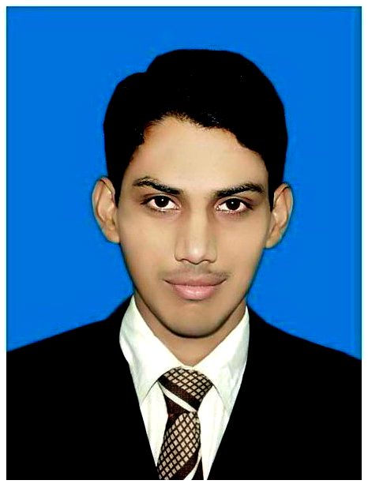
WAQAR AHMAD
Personnel Information:
Father Name: | Mukhtar Ahmad
Date of Birth: | 25-03-1985
Domicile | Faisalabad
CNIC# | 33100-2508119-1
Cell# | +92-333-8394408
E-mail | waqar_3cs@yahoo.com
Permanent Address | House No. 352 Main bazar yasinabad st # 5 Faisalabad

Objective:

To best utilize my knowledge and skills for business development of a prestigious organization and abilities to meet the challenges assigned to me.
.

Qualification:
Degree/Certificate | Institution CGPA/Marks | Year
MBA 3.5 Year | Virtual University of Pakistan 2.46 | 2015
B.COM (IT) | University of Punjab 49 % | 2008
I.COM | BISE Faisalabad 58% | 2006
Matriculation (Science) | BISE Faisalabad 51% | 2004

Major Responsibilities: Attock Petroleum Limited (09-April 2012 to Till)

6.5 Year experience as a Business Support Officer (F&A) in Attock Petroleum Limited Pansota Market near Dry port Gatti Faisalabad Telephone 041-8563161

- Fully Control the Enterprise resource planning Like E-Suite in Sale module.
- Preparing of loading notes, PUA, s and Invoices.
- Preparing of daily Invoice reconciliation report.
- Checking the sale summery reports with Indents rates daily.
- Preparing the bulk ledger & reconciliation of dealer accounts.
- Deposit the receipts into bank daily Basis.
- Update the outgoing register.
- Updating Stock Register.
- Online Payment confirm from UBL ,HBL,MCB,AKBL,NIB,BAF,
- TO manage Seal stock management & keep close co-ordination with supply chain Officer for Seal availability.

Major Responsibilities: Imran Law Chamber

3 Year experience as an assistant accountant in Imran Law Chamber
(Income & Sales Tax Consultants) 779/B Peoples Colony Faisalabad. Telephone 041-8711488

- Book Keeping
- Data Entry in different Enterprise resource planning
- Maintain Office Petty Cash
- Different Admin Task

I.T Skills:

- Three Month Certificate in Computer application from Govt. Technical Teachers Training College D- Ground Faisalabad
- MS Office (Word, Excel, Power point) 2003,2007 & 2010
- Using Business Applications
- Internet, Windows XP Installation etc.
- Work on different accounting software

Languages:

- Good written and oral skills of Urdu & English.

Interest and Activities:

- News Paper, Magazines& Book Reading, Games.

REFERENCE:-

Will be furnished on demand

