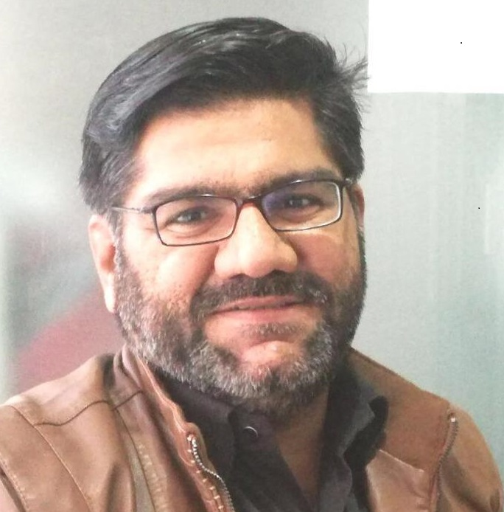
Muhammad Aslam
H#135, Al-Noor Pharmacy,
State-Life Society, Cell# (+92) 322 44 939 84
Main Road Kamahan, Lahore Email: kamahan_aslam@yahoo.com
https://www.linkedin.com/in/muhammad-asalm-2b776962/

PROFESSIONAL PROFILE
- Best Team Lead & Builder
- Outstanding command over verbal and non-verbal communicative & interpersonal skills.
- Strong organizational, managerial, problem solving, interpersonal and negotiation skills.
- Confidently able to work independently or in a team to deal effectively with educators & employees
- Valuation with due diligence
- Flair to organize & prioritize tasks to meet deadlines
- Ability to manage multiple projects with minimal supervision
- Setting Goals with marketing and business development strategies to Achieve Goals
- Competitors analysis / strategies & Post campaign analysis &Plan Customer engagement activities
- ATL media planning in coordination with ATL agency
- Media Planning & Buying (OOH) & Execution of campaigns (OOH, Activations etc)
- Analysis of budget and actual spending
PROFESSIONAL EXPERIENCE
April 2019 to onward:
Currently Working at PRINTX, BRANDX as Manager Business Development. Marketing & Sales
October 2013 to March 2019:
Worked as Manager Business Development, Marketing, Media and Operations (Business Development, Media Planning, Buying and execution) at The House of Kollaage (from Oct 2013 to March 2019) Formerly as Senior Manager Business Development, Marketing, Media and Operations.
KC is services provider in the area of OOH, ATL and BTL, Event Management, & Real estate Developer (Kollaage Concepts (Pvt) Ltd, Kollaage Concepts, Panash, Kollaage Marketing, Kollaage 360, Loom Creative , Global City, Global Avenue) 293, Block-Y, Commercial Area DHA Phase-III Lahore.

July 2010 to May 2013:
CHIEF ACCOUNTANT at Design & Print House, 26-Usman Block New Garden Town Lahore.
May 2008 to March 2010:
CHIEF ACCOUNTANT at Jamshaid and Hasan Securities (Pvt.) Limited
Corporate Member Lahore Stock Exchange.
Room No. 117 & 118 First Floor LSE Building Khayaban-e-Aiwan-e-Iqbal Lahore.
April 2007 to May 2008:
SENIOR ACCOUNTS OFFICER at Varioline Intercool Pakistan (Pvt.) Ltd Lahore.
Leading manufacturer of Commercial Refrigerators in Pakistan with annual turnover above PKR.1billion.
May 2002 to 2005 & May 2005 to April 2007
Worked for Shahkam Industries – a group with annual turnover above US$500m
a).SENIOR INTERNAL AUDITOR at Shahkam Industries (Pvt.) Ltd.
Manufacturer and exporter of knitwear a composite unit.
b). ACCOUNTS OFFICER at Premier Labels (Pvt.) Ltd.
Manufacturer of woven labels with Embroidery and Printing services to textile sector.
Feb 2000 to April 2002
ACCOUNTANT at Maknit (Pvt.) Ltd, Lahore, manufacturer and exporter of sports socks.
Azam Chowk Atta Bakhish Road Off 17 Km Ferozepur Road Lahore.

EDUCATION
Professional MBA Executive from Superior University Lahore (2015-17)

Graduated B.Com from Punjab College of Commerce Lahore (1998)
Degree awarded by Punjab University Lahore
COMPUTER SKILLS AND COMPETENCIES

MS Office
Excellent Management, Communication and Planning skills
Assertive and Competitive, Mental abilities like Divergent Thinking,

ACHIEVEMENTS
Media Planning and Buying and execution of following campaigns:
- New Jubilee Life, Jubilee Life (nationwide OOH)
- TOTAL (Hi-Perf, Quartz (Robocop), Rubia (Rubia Da mela) Nationwide OOH, BTL Activation
- UMT, Mall of defense, Global City, Global Avenue, Warda, Searle, Toyota Fortuner etc

